**F4E and EUROFUSION sign Memorandum of Understanding**

[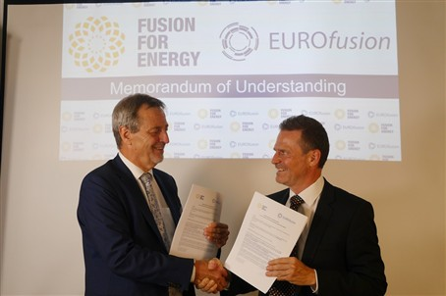](https://f4e.europa.eu/Downloads/News/P1030301-051120191200-Large.jpg)

.

F4E and EUROFUSION have signed a Memorandum of Understanding (MoU) establishing the basis for increased collaboration. The MoU was signed in September 2019 after approval by both the F4E Governing Board and the EUROFUSION General Assembly. Although the original intention was to focus on the implementation of the restructured European programme for the TBM and the Breeding Blanket, its scope is now much broader, allowing for collaboration also in the design of DEMO, Broader Approach Projects, the development and qualification of fusion materials, the ITER operation and follow-up research, and can be further extended to any other area the two organisations decide.

This collaboration is meant to benefit the EU fusion effort by bringing together the strengths of the two organisations and ensure complementarity of activities. The industrial experience of F4E will now work hand in hand with the European fusion research institutes, planning and carrying out joint work in a wide range of areas.